**1.3 Variables**

* **Description:** To show that we can also print variables using print()

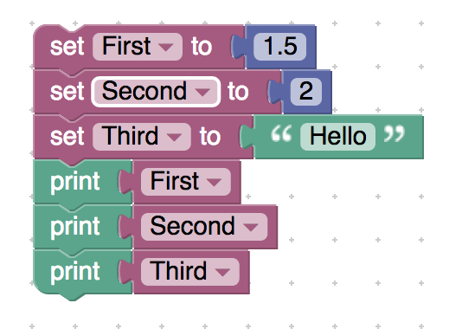

<xml xmlns="http://www.w3.org/1999/xhtml">

 <variables>

    <variable type="" id="iXrTE;WVxy^k;oOiD=`[">First</variable>

    <variable type="" id="fYk6z4K@0cfZ?cgH,iql">Second</variable>

    <variable type="" id="YzjC(|Jn@`W$}vQTp]G5">Third</variable>

 </variables>

 <block type="variables_set" id="^33v@+%8AW-.TA4:?Y;," x="388" y="-162">

    <field name="VAR" id="iXrTE;WVxy^k;oOiD=`[" variabletype="">First</field>

    <value name="VALUE">

     <block type="math_number" id="]mF[9Z8#^$Trkaxe75a[">

       <field name="NUM">1.5</field>

     </block>

    </value>

    <next>

     <block type="variables_set" id="h@2]IzCyx+D(isFyL}x+">

       <field name="VAR" id="fYk6z4K@0cfZ?cgH,iql" variabletype="">Second</field>

       <value name="VALUE">

         <block type="math_number" id="H+*(/X.Y`boqF_Z(Be1,">

           <field name="NUM">2</field>

         </block>

       </value>

       <next>

         <block type="variables_set" id="QVnqW[0wE04RhE*xh+96">

           <field name="VAR" id="YzjC(|Jn@`W$}vQTp]G5" variabletype="">Third</field>

           <value name="VALUE">

             <block type="text" id="t1PwZ+9v_2zcFhgc@]KK">

               <field name="TEXT">Hello</field>

             </block>

           </value>

           <next>

             <block type="text_print" id="m8ec8n!N+[S6mt0b?cU2">

               <value name="TEXT">

                 <shadow type="text" id="J~cV)h1S(mpk?:sGAY1s">

                   <field name="TEXT">abc</field>

                 </shadow>

                 <block type="variables_get" id="6HrQy6.eA]s!}t]3i}k@">

                   <field name="VAR" id="iXrTE;WVxy^k;oOiD=`[" variabletype="">First</field>

                 </block>

               </value>

               <next>

                 <block type="text_print" id="Y@LHTyof[VCc}gB5O*c4">

                   <value name="TEXT">

                     <shadow type="text" id="apfORQnFqQ(rZF/Pz=DV">

                       <field name="TEXT">abc</field>

                     </shadow>

                     <block type="variables_get" id="~#?Oh;~k,tn*(1#S*:;C">

                       <field name="VAR" id="fYk6z4K@0cfZ?cgH,iql" variabletype="">Second</field>

                     </block>

                   </value>

                   <next>

                     <block type="text_print" id="V,L)/jmup@Z!GS]]0!Am">

                       <value name="TEXT">

                         <shadow type="text" id="9~;c}DU]N$T-x_EP(+*C">

                           <field name="TEXT">abc</field>

                         </shadow>

                         <block type="variables_get" id="Qzvib*m^P7+!U-alN:L)">

                           <field name="VAR" id="YzjC(|Jn@`W$}vQTp]G5" variabletype="">Third</field>

                         </block>

                       </value>

                     </block>

                   </next>

                 </block>

               </next>

             </block>

           </next>

         </block>

       </next>

     </block>

    </next>

 </block>

</xml>

* **Description:** Assign a variable to another variable (Try running):

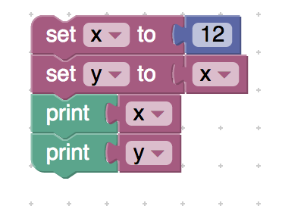

<xml xmlns="http://www.w3.org/1999/xhtml">

 <variables>

    <variable type="" id="j2)ND?%-hp1dpitN^+i^">x</variable>

    <variable type="" id="|~G.hE=O(*dM4`Y|82bZ">y</variable>

 </variables>

 <block type="variables_set" id="Rm`*BdE%yFy:r^kxVS+3" x="-213" y="-112">

    <field name="VAR" id="j2)ND?%-hp1dpitN^+i^" variabletype="">x</field>

    <value name="VALUE">

     <block type="math_number" id="5k8e-R{CU3ot:e{V9Udn">

       <field name="NUM">12</field>

     </block>

    </value>

    <next>

     <block type="variables_set" id="p2a$0=05+la8qrYmMv-%">

       <field name="VAR" id="|~G.hE=O(*dM4`Y|82bZ" variabletype="">y</field>

       <value name="VALUE">

         <block type="variables_get" id="YHKlRE2d`y#EUKC(518*">

           <field name="VAR" id="j2)ND?%-hp1dpitN^+i^" variabletype="">x</field>

         </block>

       </value>

       <next>

         <block type="text_print" id="v!0MQVJVjq@v53GVq+}K">

           <value name="TEXT">

             <shadow type="text" id="AQpg|%.vq)MVQ/C0#E{R">

               <field name="TEXT">abc</field>

             </shadow>

             <block type="variables_get" id="sYdyFX0q^DwjG0,|h,j$">

               <field name="VAR" id="j2)ND?%-hp1dpitN^+i^" variabletype="">x</field>

             </block>

           </value>

           <next>

             <block type="text_print" id="~M6ae.@u[FT(O124dTxQ">

               <value name="TEXT">

                 <shadow type="text" id="wc(;2A[_,~*4k.e,H8*)">

                   <field name="TEXT">abc</field>

                 </shadow>

                 <block type="variables_get" id="yNmgJFG8V*uu}yZ9lq0s">

                   <field name="VAR" id="|~G.hE=O(*dM4`Y|82bZ" variabletype="">y</field>

                 </block>

               </value>

             </block>

           </next>

         </block>

       </next>

     </block>

    </next>

 </block>

</xml>

* **Reassignment:** Example showing that we can reassign a new value to an existing variable

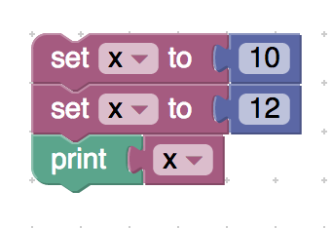

<xml xmlns="http://www.w3.org/1999/xhtml">

 <variables>

    <variable type="" id="+?B7|RlXfyp_?s~YNhdi">x</variable>

 </variables>

 <block type="variables_set" id="gWjl.?~g!9zN3jShU]t+" x="-338" y="-188">

    <field name="VAR" id="+?B7|RlXfyp_?s~YNhdi" variabletype="">x</field>

    <value name="VALUE">

     <block type="math_number" id="KkLm4jQcLF#AmGDK@v6U">

       <field name="NUM">10</field>

     </block>

    </value>

    <next>

     <block type="variables_set" id="M,?pdRj.NwB3V(h%$WkV">

       <field name="VAR" id="+?B7|RlXfyp_?s~YNhdi" variabletype="">x</field>

       <value name="VALUE">

         <block type="math_number" id=":P1=]$#OM4$GxE-fbMp#">

           <field name="NUM">12</field>

         </block>

       </value>

       <next>

         <block type="text_print" id="W{1+bUdi6F3W{95-Y4$T">

           <value name="TEXT">

             <shadow type="text" id="[AZ0`HtLAH(OJigt;HIV">

               <field name="TEXT">abc</field>

             </shadow>

             <block type="variables_get" id="EhE?w$Y-Doa}tcv+nfpd">

               <field name="VAR" id="+?B7|RlXfyp_?s~YNhdi" variabletype="">x</field>

             </block>

           </value>

         </block>

       </next>

     </block>

    </next>

 </block>

</xml>

* **Dynamic typing:**

**Description:** An example to show that you can declare a variable of any data type without specifying the data type

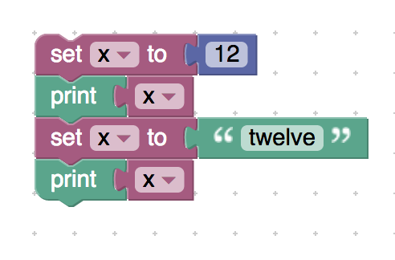

<xml xmlns="http://www.w3.org/1999/xhtml">

 <variables>

    <variable type="" id="j2)ND?%-hp1dpitN^+i^">x</variable>

 </variables>

 <block type="variables_set" id="Rm`*BdE%yFy:r^kxVS+3" x="-213" y="-112">

    <field name="VAR" id="j2)ND?%-hp1dpitN^+i^" variabletype="">x</field>

    <value name="VALUE">

     <block type="math_number" id="5k8e-R{CU3ot:e{V9Udn">

       <field name="NUM">12</field>

     </block>

    </value>

    <next>

     <block type="text_print" id="k%p[v3gC^)`A^H}BH~47">

       <value name="TEXT">

         <shadow type="text" id="ff7{+kaLa%UKuMxkP-X^">

           <field name="TEXT">abc</field>

         </shadow>

         <block type="variables_get" id="Q@d1.kzI9bAoDD.N4igS">

           <field name="VAR" id="j2)ND?%-hp1dpitN^+i^" variabletype="">x</field>

         </block>

       </value>

       <next>

         <block type="variables_set" id="vf:L!~4avnbIJ%hzn@=v">

           <field name="VAR" id="j2)ND?%-hp1dpitN^+i^" variabletype="">x</field>

           <value name="VALUE">

             <block type="text" id="R[F{rE}c[TVXkb/47~+S">

               <field name="TEXT">twelve</field>

             </block>

           </value>

           <next>

             <block type="text_print" id="Xsymp{=O6=i[|]VIu34b">

               <value name="TEXT">

                 <shadow type="text" id="B]C]?w3]Ql[$f)Jq`Mvb">

                   <field name="TEXT">abc</field>

                 </shadow>

                 <block type="variables_get" id="Piix#=YdMwUxfr`wRt3@">

                   <field name="VAR" id="j2)ND?%-hp1dpitN^+i^" variabletype="">x</field>

                 </block>

               </value>

             </block>

           </next>

         </block>

       </next>

     </block>

    </next>

 </block>

</xml>

* **Swapping:**

**Description:** Swapping the contents of 2 variables using a buffer variable

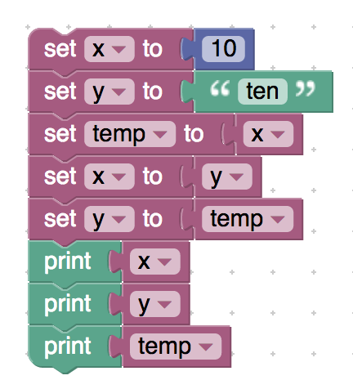

<xml xmlns="http://www.w3.org/1999/xhtml">

 <variables>

    <variable type="" id="j2)ND?%-hp1dpitN^+i^">x</variable>

    <variable type="" id="|~G.hE=O(*dM4`Y|82bZ">y</variable>

    <variable type="" id="nzr_^~^i1dSPhp([?Yau">temp</variable>

 </variables>

 <block type="variables_set" id="Rm`*BdE%yFy:r^kxVS+3" x="-313" y="-187">

    <field name="VAR" id="j2)ND?%-hp1dpitN^+i^" variabletype="">x</field>

    <value name="VALUE">

     <block type="math_number" id="5k8e-R{CU3ot:e{V9Udn">

       <field name="NUM">10</field>

     </block>

</value>

    <next>

     <block type="variables_set" id="fcWn}f6eBU{m=X1~4+DN">

       <field name="VAR" id="|~G.hE=O(*dM4`Y|82bZ" variabletype="">y</field>

       <value name="VALUE">

         <block type="text" id="RV!_joC|u;{.4s19a|@Q">

           <field name="TEXT">ten</field>

         </block>

       </value>

       <next>

         <block type="variables_set" id="qqc1m8rqr{lD:+i(jo6q">

           <field name="VAR" id="nzr_^~^i1dSPhp([?Yau" variabletype="">temp</field>

           <value name="VALUE">

             <block type="variables_get" id="3mIs|T@I!OPPh{a$1d}y">

               <field name="VAR" id="j2)ND?%-hp1dpitN^+i^" variabletype="">x</field>

             </block>

           </value>

           <next>

             <block type="variables_set" id="mMDIJ:{FFo,2z0%N?nG`">

               <field name="VAR" id="j2)ND?%-hp1dpitN^+i^" variabletype="">x</field>

               <value name="VALUE">

                 <block type="variables_get" id="yE4axwG745/7jTa`u-#p">

                   <field name="VAR" id="|~G.hE=O(*dM4`Y|82bZ" variabletype="">y</field>

                 </block>

               </value>

               <next>

                 <block type="variables_set" id="TF1Kti#;nz2uwEK%XVvN">

                   <field name="VAR" i<xml xmlns="http://www.w3.org/1999/xhtml">

 <variables></variables>

 <block type="text_print" id="m{[@,lFs%z0YKIOxj@z-" x="-112" y="-87">

    <value name="TEXT">

     <shadow type="text" id="AsESNowomU.O?]|YfrA.">

       <field name="TEXT">Hello World</field>

     </shadow>

    </value>

 </block>

</xml>="}ib%LJzs+H#)jfUv^8t,">

                           <field name="VAR" id="j2)ND?%-hp1dpitN^+i^" variabletype="">x</field>

                         </block>

                       </value>

                       <next>

                         <block type="text_print" id="BS,q|B=D#=o[arkwh)so">

                           <value name="TEXT">

                             <shadow type="text" id="S3CkTC,8NgDXHNY668iK">

                               <field name="TEXT">abc</field>

                             </shadow>

                             <block type="variables_get" id=";sY+o8Sx{AADjMJU7}*1">

                               <field name="VAR" id="|~G.hE=O(*dM4`Y|82bZ" variabletype="">y</field>

                             </block>

                           </value>

                           <next>

                             <block type="text_print" id="-|*~x,ckNN^~}}CN/!Hg">

                               <value name="TEXT">

                                 <shadow type="text" id="r!#2z}]e.e+?fP3Cv[~y">

                                   <field name="TEXT">abc</field>

                                 </shadow>

                                 <block type="variables_get" id="0oTG};gK;5)F#{~AmHx*">

                                   <field name="VAR" id="nzr_^~^i1dSPhp([?Yau" variabletype="">temp</field>

                                 </block>

                               </value>

                             </block>

                           </next>

                         </block>

                       </next>

                     </block>

                   </next>

</block>

               </next>

             </block>

           </next>

         </block>

       </next>

     </block>

    </next>

 </block>

</xml>

* **Try it yourself (swapping):**

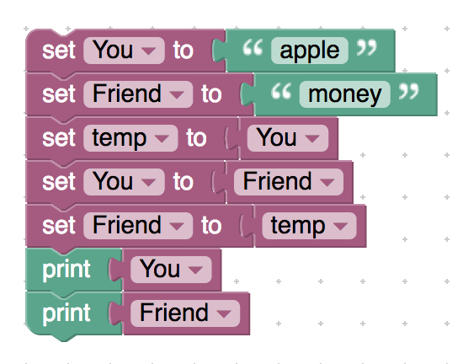

<xml xmlns="http://www.w3.org/1999/xhtml">

 <variables>

    <variable type="" id="6TairXSkJ03f*Z2Rbyvs">You</variable>

    <variable type="" id="gfY:Gyj[^66zxA}9bV@C">Friend</variable>

    <variable type="" id="nzr_^~^i1dSPhp([?Yau">temp</variable>

 </variables>

 <block type="variables_set" id="Zn/n*QugMnlF^[{gSSB{" x="-238" y="-87">

    <field name="VAR" id="6TairXSkJ03f*Z2Rbyvs" variabletype="">You</field>

    <value name="VALUE">

     <block type="text" id="14a.$RG+M7;,yd9Ck][Q">

       <field name="TEXT">apple</field>

     </block>

    </value>

    <next>

     <block type="variables_set" id="3P.d3Bry~H8jTb{#^n@g">

       <field name="VAR" id="gfY:Gyj[^66zxA}9bV@C" variabletype="">Friend</field>

       <value name="VALUE">

         <block type="text" id="PMrA4JsXL}9Ra09Jh*3=">

           <field name="TEXT">money</field>

         </block>

       </value>

       <next>

         <block type="variables_set" id="nk~REEZA{%^jPDu3r)t0">

           <field name="VAR" id="nzr_^~^i1dSPhp([?Yau" variabletype="">temp</field>

           <value name="VALUE">

             <block type="variables_get" id="xpVk[*@:tmJ{jm..%]In">

               <field name="VAR" id="6TairXSkJ03f*Z2Rbyvs" variabletype="">You</field>

             </block>

           </value>

           <next>

             <block type="variables_set" id="-%WZiNA.qdI5D0UB~o`C">

               <field name="VAR" id="6TairXSkJ03f*Z2Rbyvs" variabletype="">You</field>

               <value name="VALUE">

                 <block type="variables_get" id="zjb~OvgLouD7DfW!Zsr/">

                   <field name="VAR" id="gfY:Gyj[^66zxA}9bV@C" variabletype="">Friend</field>

                 </block>

               </value>

               <next>

                 <block type="variables_set" id="fzVF_jq+#xkRjS-bXLy?">

                   <field name="VAR" id="gfY:Gyj[^66zxA}9bV@C" variabletype="">Friend</field>

                   <value name="VALUE">

                     <block type="variables_get" id="-!c7d5kyWGLR88@*mX*d">

                       <field name="VAR" id="nzr_^~^i1dSPhp([?Yau" variabletype="">temp</field>

                     </block>

                   </value>

                   <next>

                     <block type="text_print" id="eA4!I/J+gRuC^Idm+2WV">

                       <value name="TEXT">

                         <shadow type="text" id="?[0sW*HIKha^VQxc(1Q!">

                           <field name="TEXT">abc</field>

                         </shadow>

                         <block type="variables_get" id="OMl[dF0rfWsR8oi7#}2M">

                           <field name="VAR" id="6TairXSkJ03f*Z2Rbyvs" variabletype="">You</field>

                         </block>

                       </value>

                       <next>

                         <block type="text_print" id=".?kk9I?zYlrWwGcZ2u6I">

                           <value name="TEXT">

                             <shadow type="text" id="r[Dw[;#G772al=K02vb:">

                               <field name="TEXT">abc</field>

                             </shadow>

                             <block type="variables_get" id="w!sYgtIT{!|x(kZqiD;w">

                               <field name="VAR" id="gfY:Gyj[^66zxA}9bV@C" variabletype="">Friend</field>

                             </block>

                           </value>

                         </block>

                       </next>

                     </block>

                   </next>

                 </block>

               </next>

             </block>

           </next>

         </block>

       </next>

     </block>

    </next>

 </block>

</xml>